CYCLOTHONE 2020

IMC Chamber of Commerce and Industry in association with Ratna Nidhi Chairtable Trust aims to create awareness for the empowerment of people with disabilities by organizing a Cyclathon event.

Cyclothon 2020 is an initiative to spread awareness about orthopedic disability through a unique activity. Stefan Voorman, an inspiration for many physically disabled individuals, would be cycling from Kolhapur (Maharashtra) to Mahalakshmi (Mumbai) covering a distance of about 650 kms over a span of a week. This amazing event is scheduled to take place in February 2020.

The event would be flagged off from Kolhapur tentatively on 12th February- Monday. On the last day (19th February) of the event we would have a small ceremony at Mumbai where the chief guest would felicitate Stefan for his valiant endeavor and give credits to all stake holders.
THE PARTICIPANTS
- Rotary District 3141
- Rotary District 3131
- Rotary Clubs of Kolhapur
- Iron man Kolhapur
- ZP CEO Kolhapur
- District Governor of Rotary Kolhapur
- Rotary club of Satara
- Nasik Run Group
- BOSCH India Ltd-Nasik
- ZP CEO Nasik
- MIT World Peace University, Pune
- Let’s Bridge IT
- City of Kalsruhe
- Collectors of Kolhapur, Satara, Nashik, Pune
- Govt. Medical Colleges in each area who are already our partners in our Vision 1 Million project
- Schools and Colleges
- Corporates
- Cyclist groups in different cities

Safety measures
A caravan, a car, a doctor and a physiotherapist shall accompany Stefan & cycling team throughout the one-week activity for the purpose of any medical emergencies that arise during the course of the journey.
Our Partners
We have collaborated with Somedi Nettetal Germany, IMC chambers of Commerce and Industry and Rotary International district 3141

ITINERARY
Date | Time | Location | What
12th Feb | 7:00 am | Kolhapur to Karad (72 km) | 1. RNCT intro  2. Intro Somedi Nettetal  3. Intro of IMC chamber of Commerce  4. Rotary International dist 3141  5. Intro Stefan  6. GOH speech  7. About Cylothon  8. Agenda  9. Ribbon ceremony
13th Feb | 7:00 am | Karad to Satara (51 km) | Ribbon ceremony and resume cycling
14th Feb | 7:00 am | Satara to Pune (126 km) | Ribbon ceremony and resume cycling
15th Feb | 7:00 am | Pune to Narayangaon (90 km) | Ribbon ceremony and resume cycling
16th Feb | 7:00 am | Narayangaon to Sangamner (67.5 km) | Ribbon ceremony and resume cycling
17th Feb | 7:00 am | Sangamner to Nasik (69 km) | Ribbon ceremony and resume cycling
18th Feb | 7:00 am | Nasik to Thane (144 km) | Ribbon ceremony and resume cycling
19th Feb | 7:00 am | Thane to Mumbai (25 km) | "ride till the venue, closing ceremony  1. Vote of thanks,  2. felicitation  3. Press brief  4. Food "

Meet our Lead Cyclist: Stefan Voormans
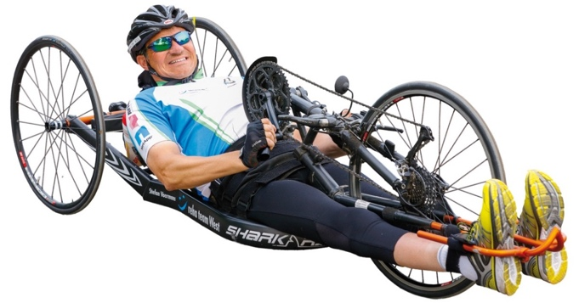
Born on 7th November 1970 in Nettetal, Germany, Stefan met with an accident on 10th December 1987, with a scooter. He became paralyzed because of the accident. Till date, Stefan has spent over three years in hospitals undergoing 64 surgical operations.
Since 2002, he started handcycling and took part in many races around the world – most of them in marathon distances of 42 kms. He won the German Championship in Paratriathlon in 2010, stood 7th at the New York Marathon in 2006 and came 4th twice at Beirut Marathon in 2009 & 2010. Since 2005, he has also been the Executive Director of Somedi Nettetal e.V., a German NGO.
To know about Stefans achievements and associations in India click here

